***Biology notes:***

***Topic 5 -Homeostasis and response:***

**Homeostasis - introduction:**

* Homeostasis
  + Maintaining a stable internal environment in response to changes in both internal and external conditions
    - The conditions inside your body need to be kept steady especially when there are external environment changes
    - Cells need the right conditions in order to function properly
  + Automatic Control systems
    - You have loads of automatic control systems which regulate your internal environment
      * These include the nervous and hormonal communication systems
      * They do this using a mechanism called negative feedback. When the level of something gets too high or too low, the body uses negative feedback to bring it back to normal
    - They are made up of three main components, which work together to maintain a steady conditions
      * Receptors
        + Detects a stimulus (change in environment)
      * Coordination centres
        + Receives and processes information and then organises a response
      * Effectors
        + Produces a response which counteracts the change and restores the optimum level

**The Nervous System:**

A single-celled organism can just respond to its environment, whereas the cells of a multicellular organism need to communicate with each other first

For this reason, they developed nervous and hormonal communication systems

What is the nervous system made up of?

* Central Nervous System (CNS)
  + In vertebrates, (animals with backbones) this consists of the brain and spinal cord only
  + In mammals, the CNS is connected to the body by sensory neurones and motor neurones
  + CNS is the coordination centre, it:
    - Receives information from the receptors
    - Coordinates a response
    - The response is then carried out by the effectors
* Effectors
  + All your muscles and glands which respond to nervous impulses and bring about a change
  + Muscles and glands respond in different ways
    - Muscles contract in response to a nervous impulse
    - Glands secrete hormones
* Receptors
  + The cells that detect stimuli (a change in environment) #
  + There are many different types of receptors, including:
    - Taste receptors, on the tongue
    - Sound receptors, in the ears
    - Light receptors, covering the retina of the eye
* Sensory Neurones
  + The neurones that carry information as electrical impulses from the receptors to the CNS
* Motor Neurones
  + The neurones that carry electrical impulses from the CNS to effectors

Flowchart example:

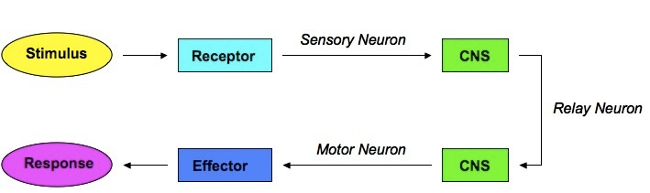

***Stimulus 🡪 Receptor 🡪 Sensory neurone 🡪 CNS 🡪 Motor Neurone 🡪 Effector 🡪 Response***

**Synapses and Reflexes:**

* What is a synapse?
  + The connection between two neurones
* The nerve signal is transferred by chemicals which diffuse across the gap,
* These chemicals then set off a new electrical signal in the next neurone
* What is a reflex?
  + A rapid, automatic response to certain stimuli that don’t involve the conscious part of the brain
    - This can reduce the chances of being injured
    - Examples:
      * If someone shines a bright light in your eyes, your pupils automatically get smaller so that less light gets into the eye, this stops it getting damaged
      * If you get a shock, your body releases the adrenaline hormone automatically, it doesn’t wait for you to realise you’re shocked
  + The passage of information in a reflex (from the receptor to the effector) is called a **reflex arc**

* How does it work?
  + The neurones in reflex arcs go through the spinal cord or through an unconscious part of the brain
  + When a stimulus is detected by receptors, impulses are sent along the sensory neurone
  + Impulses are passed along a relay neurone, via a synapse
  + Impulses travel along a motor neurone, via a synapse
  + When impulses reach the muscle, it contracts
  + As it is passed from the relay to motor, It doesn’t have to go to the brain, therefore it happens quicker

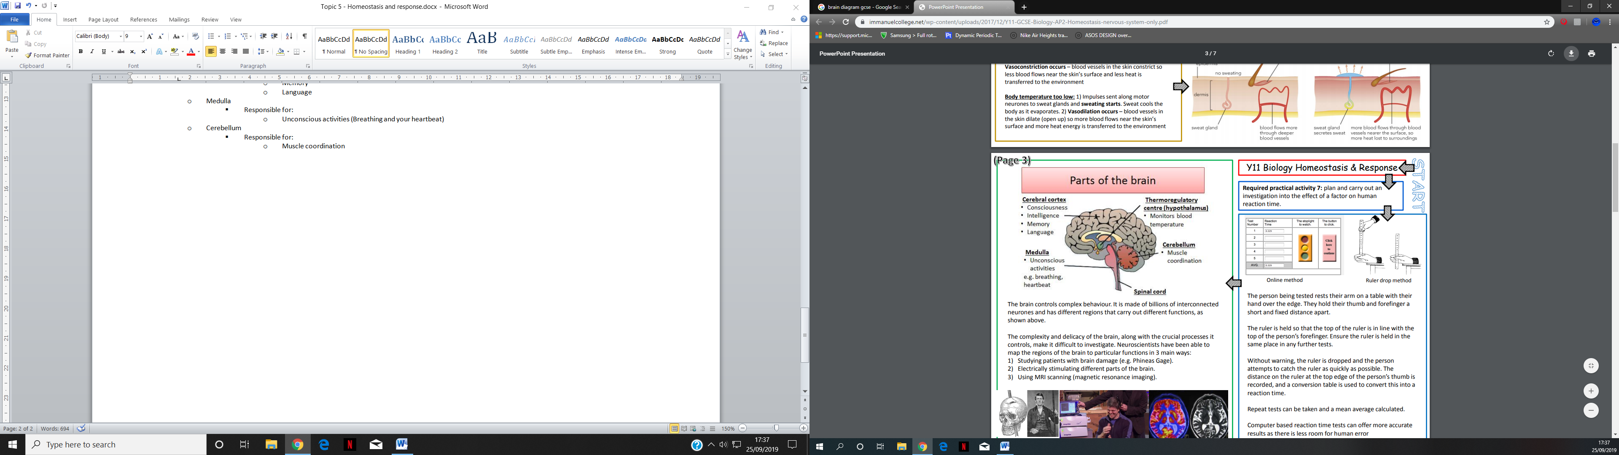**The Brain:**

The brain is responsible for complex behaviours

* The brain is part of the central nervous system
* It’s made up of billions of interconnected neurones (a nerve cell)
* It controls and coordinates everything you do
* Different regions of your brain carry out different functions
* How do scientists study the brain?
  + Scientists use a few different methods to study the brain
    - Studying patients brains with brain damage
      * If a small part of the brain has been damaged, you can tell what the damaged part is by the effects it has on the patient. For example, if they suffer memory loss, you know the Cerebral cortex has been damaged
    - Electronically stimulating the brain
      * The brain can be stimulated electrically by pushing a tiny electrode into the tissue and giving it a small zap of electricity. By observing what stimulating different parts of the brain, it’s possible to get an idea of what those parts do. For example, when the motor area of a brain is stimulated, it causes muscles to contract and move
    - Magnetic resonance imaging scanner (MRI scans)
      * A MRI scanner is a tube like machine which can produce a very detailed picture of the brains structures. Scientists use it to find out what areas of the brain are active when people are doing certain things.

Scientists have studied the brain a lot and it leads to them being able to treat disorders, however the brain is incredibly complex and to investigate and to treat brain damage or disease can lead to further issues